July 21, 2016

North Star BlueScope Steel



Delta, Ohio

RE: NSBS RxE OpenTrac Update 2016

Dear Mr. Steve Markward

AS&E, an NSBS approved vendor, is pleased to present this Time and Materials quote for changes to the RxE system to accommodate the OpenTrac interfacing.

The scope of work under this proposal is described in the accompanying document, and the first task in this work will be to finalize any remaining questions raised in this document. The work includes:

* Finalizing design details
* Configuring, coding, and testing the interface
* Updating the documentation
* Assistance in installation and monitoring

The work would be performed by Dan Houck. The work estimate is 120 hours at the hourly rate of $95, and any travel expense (two trips are envisioned) incurred will be billed at cost plus 10%.

Once a Purchase Order is received, AS&E would be available to begin the task work immediately upon acceptance of order, with the conclusion of work being anticipated for October, 2016.

We appreciate your consideration for this work. Please feel free to contact us with any questions or issues.

Sincerely,

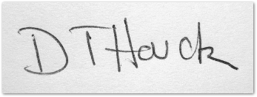

Daniel Houck

Enclosure: NSBS RxE OpenTrac Update Plan.docx

cc:

Ken Hutchison

Kathy Harrington